
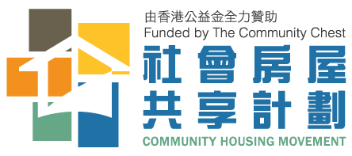
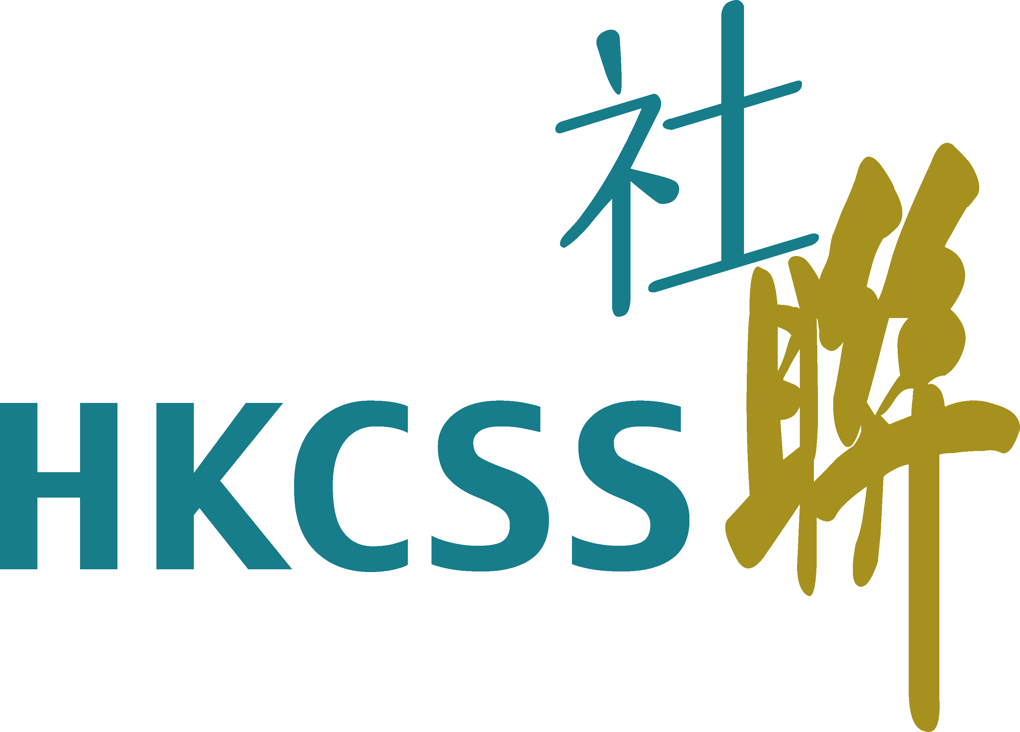
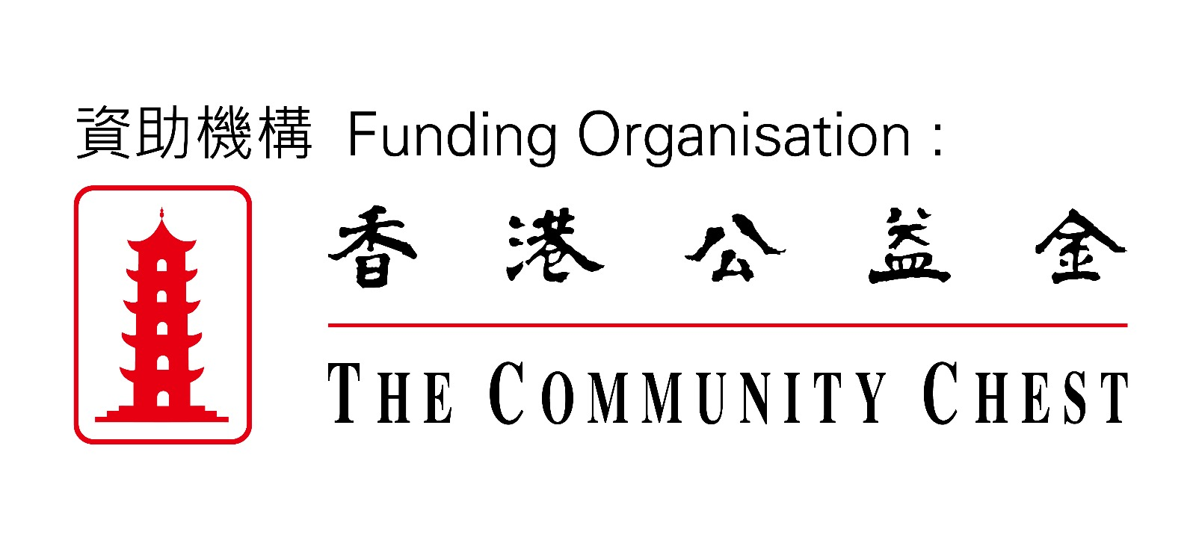

‘Good Homes’To Kwa Wan Road Community Housing Movement
For Internal Use
Received Date：
Application No.：
Application Form
Project Brief
The mission of this project is “Co-housing, Co-managing & Co-living”, which originates from the concept of sharing. Sharing refers to the social interaction among people and involves reallocating unused resources, skills and spaces for reuse. “Co-housing” means to share a living area with another family. “Co-managing” means that residents are required to coordinate and manage public space, including the living room, kitchen, and bathroom. “Co-living” means residents shall establish mutual help, trust, acceptance and patience and strive for a harmonious living environment.

Part 1 Information of the Applicant (Please fill in or tick the appropriate box)
Name of applicant: Phone no. (home): Mobile:
Address: |  |  | Total area of current flat: ____(square feet)
Type of current flat: □Permanent Flat □Temporary Flat □Partitioned Apartments /Bed □Sub-divided Flats □Others:
Average monthly rent in the past 3 months (utilities fees excluded): HKD$ __________________________
Period stayed in current flat： __________ years (or/and) _______________ months
Number of family member(s): | Public Rental Housing application no.: | Application date for Public Rental Housing: (YYYY) (MM)  Waiting time for Public Rental Housing: (year) (month)
Furniture intended to be moved into new flat:
□Bed (Type: Size: Quantity: ) □Table/Desk (Type: Size: Quantity: ) □Chair (Type: Size: Quantity: )
□ Refrigerator (Size: ) □ Washing Machine (Size: ) □ Television (Size: )
Current living condition (score 1 to 10, score 1= most dissatisfied, score 10 = most satisfied):
How many neighbors did you know in your currently living place at same block? _________person(s)
How often do you interact with those neighbors? □ Never □ Few □ Sometimes □ Often □ Always
Are you receiving any services from any social service organizations?
□ Yes (Please specify: ____________________ e.g. family support services, child and youth services, community services or day care centre for the elderly etc.) □ No
Tend to move in date: _____________________________________________________________________________________
Part 2 Personal Data (Please fill in or tick the appropriate box)
 | Applicant | Family Member 1 | Family Member 2 | Family Member 3 | Family Member 4 | Family Member 5
Name in Chinese | --
Name in English | --
Gender | □ M □ F | □ M □ F | □ M □ F | □ M □ F | □ M □ F | □ M □ F
Date of Birth (DD/MM/YYYY) (age) | / /  ( ) | / /  ( ) | / /  ( ) | / /  ( ) | / /  ( ) | / /  ( )
Type of identity document | □1 □2 □3  □4 □5 □6 | □1 □2 □3  □4 □5 □6 | □1 □2 □3  □4 □5 □6 | □1 □2 □3  □4 □5 □6 | □1 □2 □3  □4 □5 □6 | □1 □2 □3  □4 □5 □6
Identity document no.
Relationship with applicant | /
Period living in HK
(months)
Marital Status | □Unmarried  □Married  □Divorced  □Widowed  □Separated  □Others: __ | □Unmarried  □Married  □Divorced  □Widowed  □Separated  □Others: __ | □Unmarried  □Married  □Divorced  □Widowed  □Separated  □Others: __ | □Unmarried  □Married  □Divorced  □Widowed  □Separated  □Others: __ | □Unmarried  □Married  □Divorced  □Widowed  □Separated  □Others: __ | □Unmarried  □Married  □Divorced  □Widowed  □Separated  □Others: __
Pregnant over 16 weeks? | - Yes, Pregnant duration: weeks □ No
Chronic illness /disability (please specify)
Any special education need? | / | □ | □ | □ | □ | □

Part 3 Income & Net Asset Value (in Hong Kong dollars)

 | Applicant | Family Member 1 | Family Member 2 | Family Member 3 | Family Member 4 | Family Member 5
Working Status | □ Full-time  □ Part-time  □ Unemployed  □ Retired  □ Housewife  □ Studying | □ Full-time  □ Part-time  □ Unemployed  □ Retired  □ Housewife  □ Studying  □ Not started school | □ Full-time  □ Part-time  □ Unemployed  □ Retired  □ Housewife  □ Studying  □ Not started school | □ Full-time  □ Part-time  □ Unemployed  □ Retired  □ Housewife  □ Studying  □ Not started school | □ Full-time  □ Part-time  □ Unemployed  □ Retired  □ Housewife  □ Studying  □ Not started school | □ Full-time  □ Part-time  □ Unemployed  □ Retired  □ Housewife  □ Studying  □ Not started school
Occupation
Personal average monthly income in the past 6 months | (A) | (B) | (C) | (D) | (E) | (F)
Household Average Monthly Income² in the past 6 months (A) + (B)+(C)+(D)+(E)+(F)= $ _______________per month
Total monthly income from government’s social security | □ 1. Comprehensive Social Security Assistance (CSSA) Scheme $  □ 2.Social Security Allowance (SSA) Scheme $ _________________  □ 3.Old Age Living Allowance $ □ 4. School Textbook Assistance Scheme $ □ 5.Low-income Working Family Allowance (LIFA) $ □ 6. Other:________________ ____ $
Household Average Monthly Income in the past 6 months (including government’s social security): $ _____per month
Household Net Asset Value  (supporting documents required) | □ 1. Deposits $ ___ □ 2. Insurance $  □ 3. Shares $ ______ □ 4. Property $ ______  □ 5. Funds $ ________ □ 6. Vehicles $ ________  □ 7. Others $ ________
Total Net Asset Value of the Household (1+2+3+4+5+6+7)= $ ____________________________________
Part 4 “Co-housing, Co-managing & Co-living”
Do you agree with the concept as mentioned below (You may choose more than one option):
□ I agree with the concept of “Co-housing, Co-managing & Co-living”.
□ I am willing to share the communal living area (excluding bedrooms) for others’ usage, e.g. child care support, tutoring service, interest class etc.
□ I am willing to share my talents and time to help other people, e.g. □ Cooking □ Tutoring □ Hairdressing □ Child care
□ Sewing □ Visit activities □ Home repair
□ Other: ______________________
□ I am willing to coordinate with the co-living household on how to manage the communal area, keep up a safe and hygienic living environment.
Have you applied for the Community Housing Movement Scheme organized by other organizations?
□ Yes, already got an offer
□ Yes, on the waiting list
□ Yes, but not successful
□ No

Part 5 Expectations for the Project
Please write down your expectations for “Co-housing, Co-managing & Co-living”.

__

Part 6 Declaration of the Applicant and Family Members (Please tick the appropriate boxes)
1. □ I/We have read carefully and understood all the application procedures, guideline and criteria before completing the Application Form. I/We undertake to comply with the relevant requirements/arrangements contained therein, as well as all application/allocation policies and arrangements as may be imposed from time to time. Hong Kong Sheng Kung Hui Welfare Council Limited (Welfare Council) shall have the final decision on housing allocation.
2. □ Apart from this application, I/we have not applied for any other social housing scheme organized by Hong Kong Council of Social Service (HKCSS) or other non-government organizations;
3. □ As at the date of completing my/our Application Form, I/we have not owned, co-owned, entered into any agreement to purchase or held more than 50% of shares in a company which owns (directly or through its subsidiary) any domestic property in Hong Kong;
4. □ I/We agree that Welfare Council may, in processing my/our application, collect my/our personal data from relevant government departments, public/private organizations (such as but not limited to financial institutions and banks), and/or any other third party (such as but not limited to employers) possessing my/our personal data for verification and confirmation of my/our eligibility. Whilst the collection of information is in progress, the personal data contained therein may be disclosed to the abovementioned organizations and/or any other third party. In this connection, I/we authorize these organizations and/or any other third party possessing my/our personal data to furnish Welfare Council with my/our personal data for the vetting of my/our application.
5. □ I/We agree that Welfare Council may, in handling, processing and/or investigating on my/our application, disclose, verify and/or transfer my/our personal data in this Application Form and all relevant documents to relevant departments, organizations and/or cooperating entities. All personal data will be handled in accordance with the policies adopted by Welfare Council from time to time and the Personal Data (Privacy) Ordinance (Cap. 486).
6. □ I/We agree that the personal data in this Application Form can be used for statistical survey or research.
7. □ I/We declare that all the above particulars furnished in this Application Form and all information submitted/ to be submitted are true and correct. I understand that if I/we knowingly make any false statement or furnish any false information or mislead Welfare Council in any other ways, I/we may be prosecuted and immediately lose my/our eligibility for application, or may be required to immediately cease to use the flat. I/We understand that any person who intentionally provides false information or omits information in an attempt to fraudulently obtain eligibility for the project commits an offence.
8. □ I/We understand and agree that I/we need to move out of the flat at the end of this project or upon receiving an offer of public housing.
9. □ I/We agree to download the “Co-living sharing platform” App in order to obtain co-housing information and actualize the concept of “Co-housing, Co-managing & Co-living”.
10. □ I understand and agree that nothing in this Application Form and/or relevant agreement(s) confers or purports to confer on any third party any benefit or any right to enforce any term of this Application Form and/or relevant agreement(s) pursuant to the Contracts (Rights of Third Parties) Ordinance (Cap. 623).

The Applicant and all family members aged 18 or above who are listed in Part 2 are required to sign below. The Applicant shall be held liable for the data of family member(s) aged below 18 furnished herein.

 | Name | Identity Document No. | Signature
Applicant | ________________________ | ________________________ | ________________________
Family Member 1 | ________________________ | ________________________ | ________________________
Family Member 2 | ________________________ | ________________________ | ________________________
Family Member 3 | ________________________ | ________________________ | ________________________
Family Member 4 | ________________________ | ________________________ | ________________________
Family Member 5 | ________________________ | ________________________ | ________________________
Date：
Part 7 Application Result (For Internal Use)

- Verification of information □ Pass □ Fail Signature of Staff: ( ) Date:
- Move In Date: (YYYY) (MM) (DD)
- Recommendation after interview
Date of Interview: ______ Result：□ Pass □ Fail
Move In Date: Total no. of people in the flat: Monthly License Fee:
Remarks:
Signature of interviewer: ( ) Date:

- Result of Application
□ Approved ( □ Allocated Flat: ___ □ Waiting number: )
□ Fail (Reason(s) : )

Signature of supervisor: ( ) Date:

Part 8 Checklist of Supporting Documents
1. Identity Documents of Applicant and Family Members
Copy of the identification documents of individual family members | - Hong Kong Smart Identity Card (for persons aged 11 or above)  - Birth Certificate (for persons aged below 11).  - One-way Permit / travel document / passport or related supporting documents(persons who have arrived in Hong Kong for less than 7 years, documents permitting them to land in Hong Kong with the stamp showing the initial date of entry are required).
Copy of relationship proof | - Birth certificate or notary public certificate.  - Adoption or Appointment of Guardians documents issued by judicial authorities / government departments.
Copy of documents on marital status for married persons | - Certificate of Marriage. For customary marriage celebrated in Hong Kong, the original of a statutory declaration.  - For the spouse of an applicant / a family member who has no right to land in Hong Kong, a declaration specifying the same together with copy of the certificate of marriage and the identity document of his / her domicile (both front and back sides).  - For a marriage registered on the mainland but without the relevant document, copy of the notary public certificate.
Divorced persons, unmarried single parent or widowed persons | - Copy of court order of divorce (for proceedings in Hong Kong, the certificate of making Decree Nisi Absolute (Divorce) (Form 6 or 7B)).  - For applications including children under the age of 18, copy of the court order for the custody of children.  - Copy of documents and declaration relating to divorce proceedings under process.  - For separated cohabitees, the female should submit the original of a statutory declaration stating the date of separation after co-habitation and arrangements for the custody of child(ren); while the male should submit a copy of the court order for the custody of child(ren).  - For deceased spouse, copy of the marriage certificate and death certificate.  - Declaration.
Proof of Address | - Copy of any document bearing the Applicant’s residential / correspondence address in Chinese / English (e.g. electricity or water bill).
Proof of rent | - Copy of rent receipt or tenancy agreement.
Proof of public housing application | - Copy of a blue acknowledgement card bearing an application number offered by the Hong Kong Housing Authority.
With pregnancy of 16 weeks or more | - Copy of medical proof issued by registered medical practitioners.
For having long term diseases/disabled family member | - Copy of medical/disability proof issued by registered medical practitioners or recognized medical personnel.
2. Income Proof and Relevant Declarations for Applicant and Family Members
Salaried employee (with a regular employer) | - Copy of Employer Certificate, tax bill, payslip or bank passbook etc.
Salaried employee (with no regular employer)/ Self-employed person | - Declaration with relevant documents
CSSA recipient | - Declaration on the source of financial support together with copy of documents indicating the amount of Comprehensive Social Security Assistance and the Certificate of Comprehensive Social Security Assistance Recipients (for Medical Waivers)
Where Applicant or Family Member are on retirement, unemployed or without any employment | - Declaration on the source of financial support
Deposit Record | - Copy of the deposit record of individual family members, e.g. bank passbook, monthly statement etc.
Leased / Vacant land / Landed properties | - Copy of the latest demand note for rates and government rent  - Declaration
Other sources of income (dividends, bonus,  Dividends / giving-outs of insurance policies, regular interest on fixed deposits, pension, contributions from relatives, etc) | - Copy of pension documents  - Declaration

Types of identity document: 1. Hong Kong Permanent Identity Card；2. Hong Kong Identity Card；3. Birth Certificate (Applicable for children under age 11)；4. HKSAR Re-entry Permit；5. Document of Identity for Visa Purposes Hong Kong Special Administrative Region People's Republic of China；6. Permit for Proceeding to Hong Kong and Macau (One-way Permit)
Income includes: income from employment and other income (including salary, double pay, allowance, year-end bonus/commissions, business or investment profit, alimony, subsidy from relatives and friends, interest earned from savings and shares, rent income, pension, gratuity); excluding MPF contributions, government funding, charity donation and Community Care Fund)
Family Asset includes: land, property (residential units, commercial units, parking spaces), vehicles, taxi/car licenses, investments (saving insurance policies, funds, shares), business and loan to others

